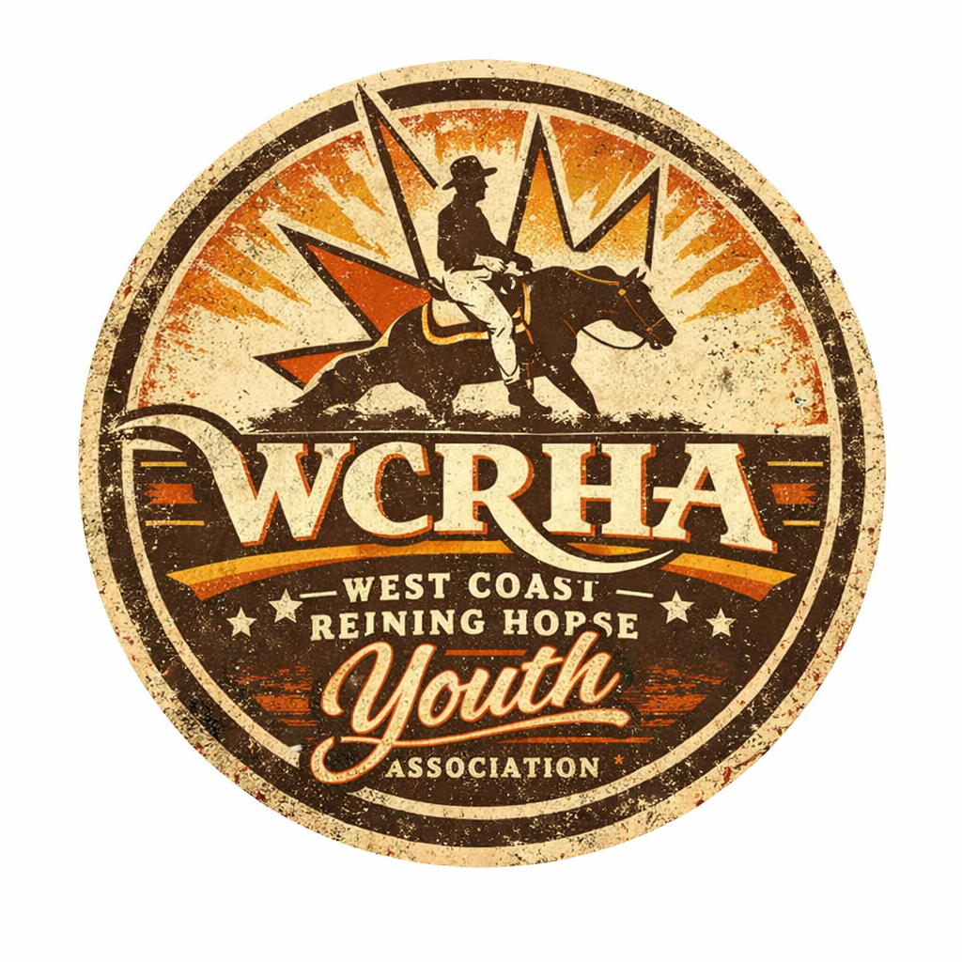
ADULT LEADLINE QUESTIONARE
We are so excited that you are performing in this class. The Rider has to be over the age of 18 years old. The leader can be any one that wants to participate. Thank you for supporting our West Coast Reining Horse Youth! We would love for our judge to get to know by filling this out.
Costumes are optional but we please ask for them to not be Spookable to the futurity horses that are warming up.

  - Riders Name:___________________________

  - Horse’s Name:___________________________

  - What is your favorite Color:____________________________

  - Who do you want to be when you grow up?_______________________
___________________________________________________________________________________

  - What is your favorite Snack?____________________________________

