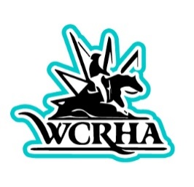

WCRHyA Scholarship Information
We take pride in our Youth in our West Coast Reining Horse Association. They put countless hours in the pen, at the barn, and in the classroom. Here at WCRHyA we grant up to (2) scholarships a year starting at $500. If there are more than multiple candidates, youth delegates will have the option to approve further scholarships based on available funds.
Applications will be reviewed by the youth director and board members of the WCRHA and candidates will be voted upon. Scholarship(s) will be awarded at Year End Banquet. Money will not be sent directly to individual but to the institution where the scholarship winner is enrolled at. Winner will have until their 22nd birthday to use scholarship money, after that the scholarship will be forfeited.
WCRHyA Scholarship Requirements:
(Candidates must meet the following to apply for scholarship)
- Application must be postmarked by January 1st, 2025 for consideration.
- Must be a current WCRHA member.
- Candidate must be graduating high school/in senior year in 2025 with the intent to pursue a degree at a two- or four- year institution, trade school, or technical school.
- All applicants must complete the scholarship application that includes questionnaire, submission of one letter of recommendation from either a trainer, teacher, WCRHA member, or coach (no family members).
- We are looking for candidates that have been active in WCRHyA throughout the year in and out of the arena from fundraisers and being a team player in the club. Tell us how WCRHyA has helped you as and individual in and out of the classroom.
If you have any questions on WCRHyA Scholarship please feel free to contact
Kelley Holcomb-Stannard at (559) 708-1470

